PM-02 - Folder structure:
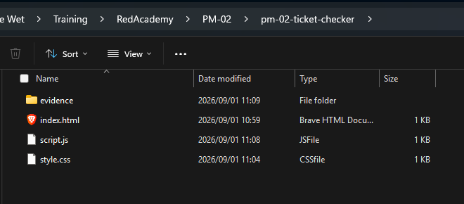

Practice Exercise 1:
Code:
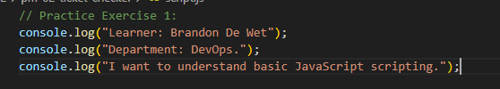
Test evidence:
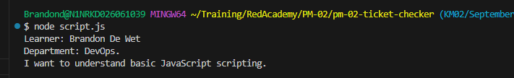
Question:
- JavaScript statement - is an instruction given to a computer to perform a specific action.
- What does console.log() do? - console.log() is used to display output performed by the JavaScript, can be used for debugging.
- Where do console messages appear? - This appears in the developer tools option on a browser under the console settings.
- Why should learners save and refresh after changes? - This is done to clear any cache the browser might save which can prevent user from seeing their changes.
- What is one common syntax error? - Forgetting to close quotations

Practice Exercise 2:
Code:
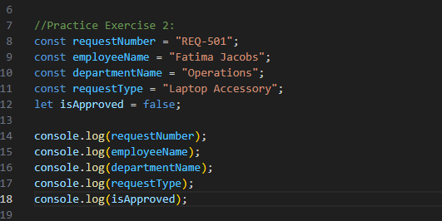
Test evidence:
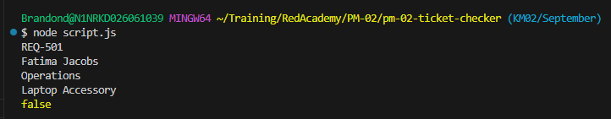
Questions:
- What is a variable? - Variables are used to store information which can be re-used later.
- When should you use let? - Let should be used when you want a value of the variable to be changed regularly.
- When should you use const? - Const should be used when you do not want a value of the variable to be regularly changed, if not ever.
- Why are meaningful names important? - Having meaning names in your code increases code readability and allows for ease of traversal should you need to update or debug something.
- Can a const value be reassigned? - Yes const values can be reassigned.

Practice Exercise 3:
Code:
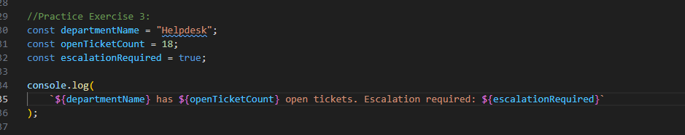
Test evidence:
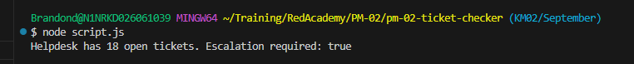
Questions:
- What is a string? – A string is a Text Value.
- What is a number? – A number is datatype, can be used for calculations
- What is a Boolean – This datatype is used to determine True or False conditions.
- What does type of do? - Type of is used to determine what datatype is being used for a value.
- Why is “10” different from 10? – “10” is a string indicated by “” and 10 is a number, these are not the same because their datatypes are different.

Practice Exercise 4:
Code:
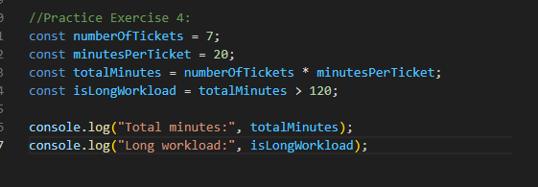
Testing Evidence: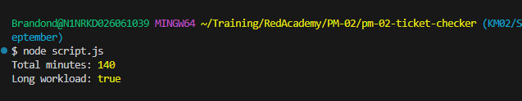
Questions:
- What does an arithmetic operator do? – These are when you use operators to add, subtract, multiple or divide numeric values to get a calculated output.
- What does === check? – This is used to strictly check that values match the given condition based on its value and datatype.
- What does && mean? – AND, both conditions must be true.
- Why do comparison operators return true or false? – compare values and return a Boolean result which would return true or false.

Practice Exercise 5:
Code:
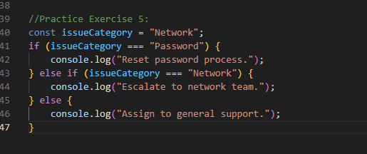

Testing Evidence:
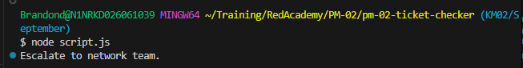
Questions:
- What does an if statement do? – runs a block of code only when a condition is true.
- When should else if be used? – should be used if you need the script to choose between two paths.
- What is the purpose of else? – Else would be used when there are more than two possible outcomes.
- What does switch help with? – A switch statement is useful when one value is compared against several possible exact values.
- Why should learners test all possible priority values? – By testing all possible priority values you will get to identify which each else statement would return.

Practice Exercise 6:
Code:
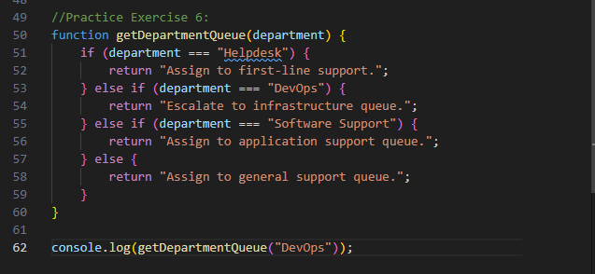
Testing:
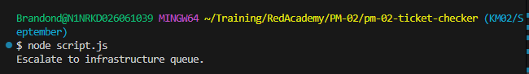
Questions:
- What is a function? – a function is reusable block of code that performs a specific task.
- What is a parameter? – It is a placeholder named used inside the function.
- What does return do? – Return is used when the program needs to use the result returned by return.
- Why are functions useful? – Functions allow code logic to be reused.
- Why should function names describe actions? – They should be specific as one can have many functions, but poorly named functions can make it difficult to navigate or read code.

Practice Exercise 7:
Code: 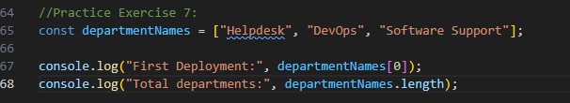

Testing:
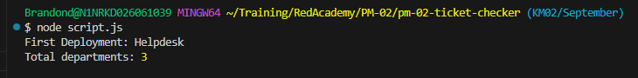
Questions:
- What is an array – allows JavaScript to store and process lists
- What index does the first array item use – 0
- What does .length show – This will show the amount of entries in a list starting from 1.
- What does push() do – when you push into the array you are adding a new item to the array.
- Why are arrays useful for support tickets – arrays allow you to store and process tickets in a list which you can then find specific items from the list.

Practice Exercise 8:

Code:
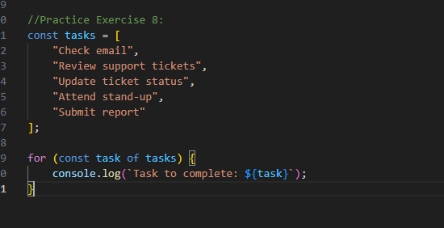
Testing: 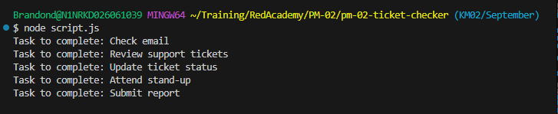
Questions:
- What does a loop do? – allow a program to repeat actions.
- Why do arrays and loops often work together? – They often work together because an array is a list of items and a loop is used to loop through all the items in an array.
- Why is for… of beginner-friendly for arrays? - provides a clean, direct way to read element values without requiring manual index tracking or length checks.
- What is easier about for.. of? – don’t need to manually track indexes or check array lengths.
- How can a loop process multiple tickets? – It can check the array until a condition is met providing multiple outputs.

Practice Exercise 9:

Code:
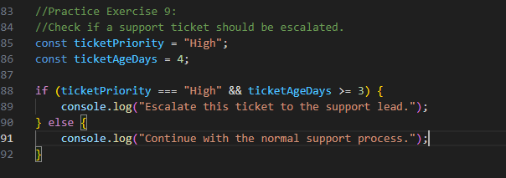
Testing:
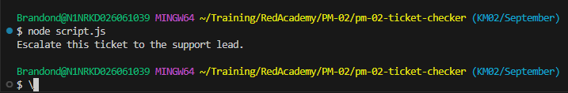
Questions:
- What is a comment? – a comment is a way to add meaningful notes to a code block
- What makes a comment useful? – comments can be used to help understand code logic with explanations on what a specific code block does.
- Why is indentation important? – Indentation is important as it helps group code blocks together and improve code readiness.
- What is camelCase? – camelCase is the case structure in which variables should be defined. E.g. totalTickets.
- Why should code be readable even if it already works? – Code should be readable so that the next group of developers can easily follow the code flow and understand which sections are pertaining to each section.

